|  |  |  |  |
| --- | --- | --- | --- |
| Description: Description: S:\AdminShared\All Staff\1 College Logo's\Baldivis_Logo_colour.jpgName: | \_\_\_\_\_\_\_\_\_\_\_\_\_\_\_\_\_\_\_\_\_\_\_\_\_\_\_\_\_\_\_\_\_\_\_\_\_\_\_\_\_\_\_\_\_\_\_\_\_\_\_ | | Date: *\_\_\_\_\_\_\_\_\_\_\_* |
|  | **Year 11 Applications**  **Test 6, 2019**  **Topics – Simultaneous Equations and Piece-wise functions** | |  |
| **Total Time:** | ***46*** *minutes* |  | |
| **Total Reading:** | ***2*** *minutes* |
| **Total Working:** | *44 minutes* |
| **Weighting:** | *8% of the year.* |
| **Equipment:** | *SCSA Formula Sheet; 1 page notes (A4 one side,* ***Unfolded****), CASIO ClassPad; Scientific Calculator, graph paper* | | |

44

= %

**Resource Free Section – 13 min 1 min reading time [13 marks]**

1. **[2 marks]**

Solve each of these linear equations

1. $\frac{4t+8}{6}=6$ b) $4n+12=3n+6$
2. **[3 marks:1, 2]**

The cost of hiring a limousine for the Year 12 ball is $175 plus $3.50 for each kilometre travelled.

1. Construct a formula to calculate the cost of hiring a limousine with this company
2. Calculate the cost of hiring a limousine to travel 36km
3. **[5 marks:2, 3]**

Solve the following simultaneous equations

|  |  |  |  |
| --- | --- | --- | --- |
| a) | $$y=2x+6$$ $$y+3x=-4$$ | b) | $$3x+5y=-9$$ $$7x+4y=2$$ |

1. **[3 marks ]**

Sketch the graphs of  and *x* = 3 on the same set of axes, and use the graph to solve the simultaneous equations.

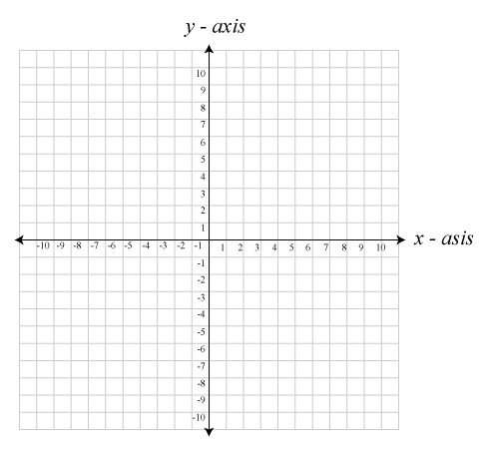

Solution:

-End of Resource Free Section-

**Resource Rich Section – 31 min 1 min reading time [31 marks]**

1. **[2 marks ]**

Express the equation 3*x* + 6*y* − 18 = 0 in the form *y* = *a* + *bx* and hence state the gradient and *y*-intercept of the line.

1. **[3 marks ]**

A taxi driver charges $15 flag fall and $5 per kilometre or part thereof. Construct a step graph to represent the taxi driver’s charges for the first 6 kilometres.

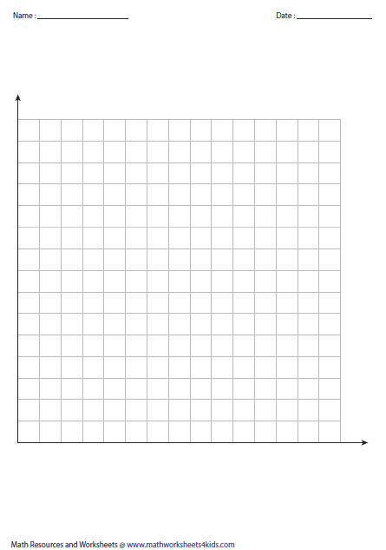

**[11 marks; 2, 2, 2, 2 and 3]**

To provide a lunchtime buffet, a catering company charge a flat fee of $150 plus an additional charge of $20 per person attending.

1. Calculate the total cost charged by the catering company for a lunchtime buffet for 12 people.
2. Complete the table below to determine the total cost ($C) of the buffet when n people attend.

|  |  |  |  |  |  |  |  |
| --- | --- | --- | --- | --- | --- | --- | --- |
| Number attending (n) | | 0 | 5 | 10 | 15 | 20 | 25 |
| Total cost ($C) | | 150 | 250 |  |  |  |  |
|  | | 1. Plot the points from the table on the axes below and join them with a dotted line. | | | | | | | |
| d) | | Write a rule to determine the total cost, C, from the number of people attending, n. | | | | | | | |
| e) | | A business has a budget of $1 000 to hire the catering company to provide a lunchtime buffet. Determine the most number of people that they can invite to the buffet if they must not exceed this budget. Show your working. | | | | | | | |

|  |  |
| --- | --- |
|  |  |
|  |  |

1. **[2 marks ]**

Find the equation of the line that passes through the points below

1. (-1, 3) and (0, 4) b) (-2,-2) and (0, 2)
2. **[4 marks ]**

To finish a project, Genevieve buys a total of 25 nuts and bolts from a hardware store. If each nut costs 12 cents, each bolt costs 25 cents and the total purchase price is $4.30, how many nuts and how many bolts does Genevieve buy?

1. **9 marks [ 1, 2, 2, 4]**

A piecewise linear equation is given below:

$$y=\left\{\begin{aligned}2x-5, -6≤x<1 \\ x-4. ≤x≤6\end{aligned}\right.$$

1. How many line segments?
2. What is the gradient of each line segment?
3. Which line segment is steeper? Why?
4. Sketch the graph of the piecewise linear equation given above, using additional graph paper

-End of Resource Rich Section-